# Working with dataset (Loading The Dataset)

|  |  |
| --- | --- |
| Date | 24 October 2022 |
| Team ID | PNT2022TMID27968 |
| Project Name | Estimate The Crop Yield Using Data Analytics |

* Before building the interactive visuals dashboard, we should view and analyze the data , you must first upload the data in IBM cognos after understanding Them. Cognos most supportive tool for this task, it can connect wide varitery of data, stored in variety of places .
* The might be stored in system storage , drive as txt file, csv file and other files , or in big data , relational or cube database on server in enterprise
* For better understanding we can go through the demo video given by IBM.

# Login Into IBM Cognos

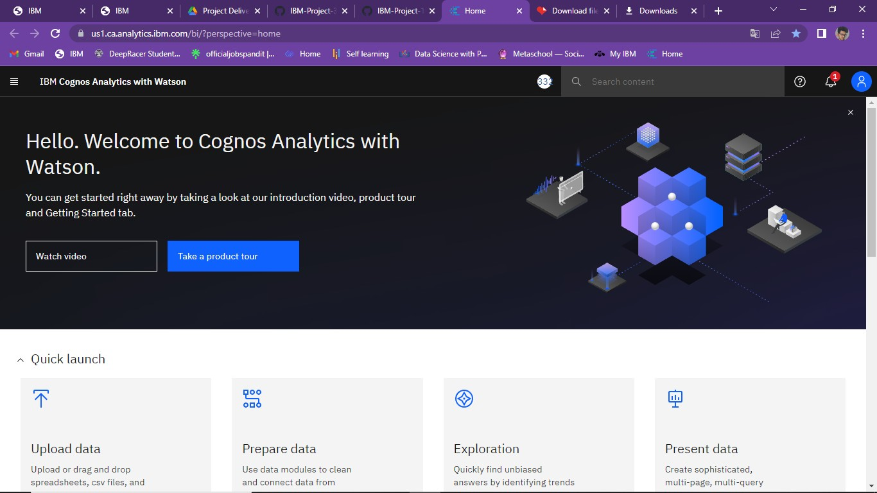

1. **Go To Menu Icon Left Click On Upload Data:**

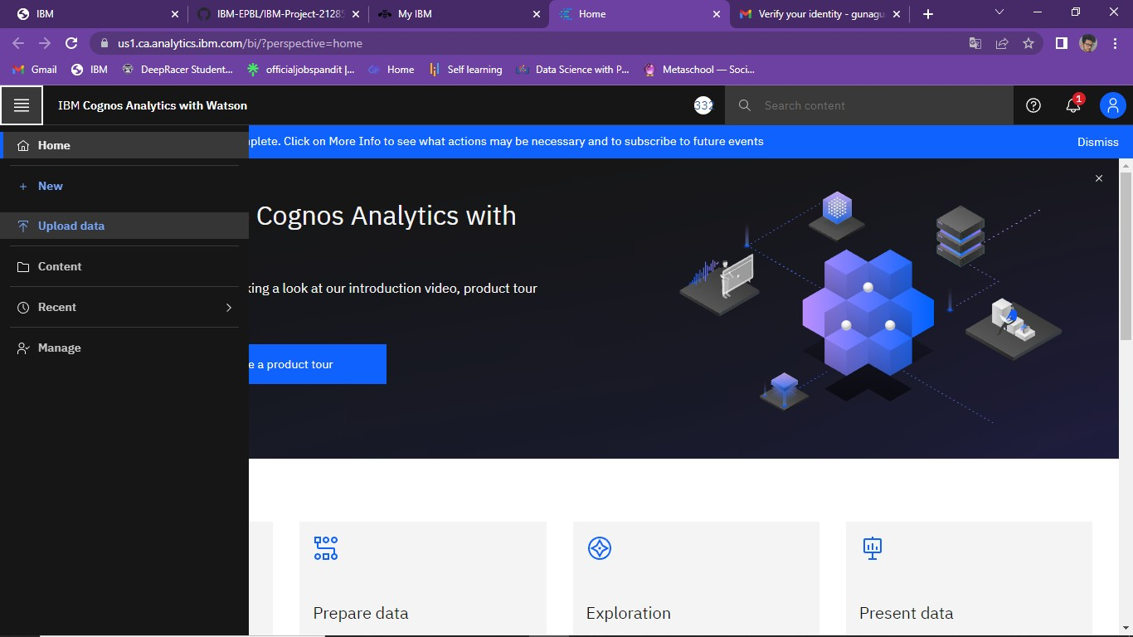

**3.Select The Needed Dataset:**

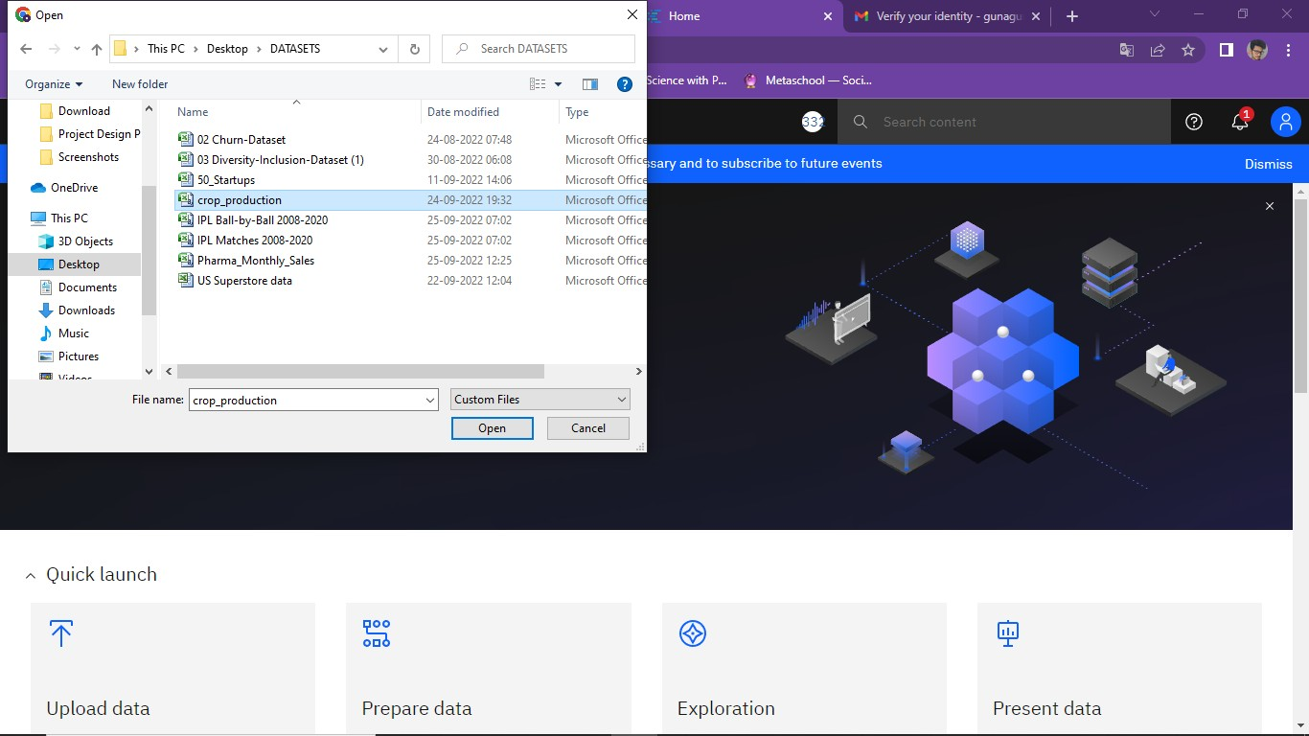

**4.Click On Open And Wait To Upload The Data:**

